9/10/2019

Rajesh Mishra

rajesh_mishra1020@hotmail.com

Job Management case study

**Job Management - Schedule Task**

**Assumption**:

1. Considering Job Management project is only applicable for Java batches (Job)
2. Considering Once Job is submitted that means it started running in background.
   1. For testing purpose I have created new Java **ReadingFileTask.java** batch.
   2. The main purpose of this job is to read file and display data on console.
3. Considering Job which we are selecting, its executable should be available in same folder of project.
4. If you have not entered any values in hours(00-23hr) and minutes(00-59 mn) textboxes then default value would be -1 for both text boxes. ***If values are -1 then this will started executing immediately***.

**Future Improvement:**

1. This system should have proper login machenism by using Authentication/Authorization process.
2. As of now this system is working on internal java data structures, in future this can be implemented by using database (which will be easy to handle states of job).
3. As of now this system is only supporting Java job, in future we can enhnace to handle python, linux batches etc.
4. We can get process id from running processes of the system by executing respective command process find in windows and linux system. And use this way to get correct states (*QUEUED, RUNNING, SUCCESS, FAILED*) of the submitted task.

**Code Repository Details:**

|  |  |  |
| --- | --- | --- |
| SR | Content | URL |
| 1 | Job Management | <https://github.com/Rajesh1761/job-management-schedule> |
| 2 | ReadingFileTask | <https://github.com/Rajesh1761/ReadingFileTask> |
| 3 | Build Jar | <https://github.com/Rajesh1761/Job-management-schedule-build/> |

**Case Study Diagram:**

**How to start this process:**

1. Download build project from [**URL**](https://github.com/Rajesh1761/Job-management-schedule-build/)(<https://github.com/Rajesh1761/Job-management-schedule-build/>)
2. Unzip project folder and u will get following files
3. Right click on ***Job-management-case-study-execute.bat*** and open it.
4. Command promt will open and it start executing, it will have one testing record named (Task1)
5. This will open your defualt browser with URL (<http://localhost:9000/job-management/dashboard>)

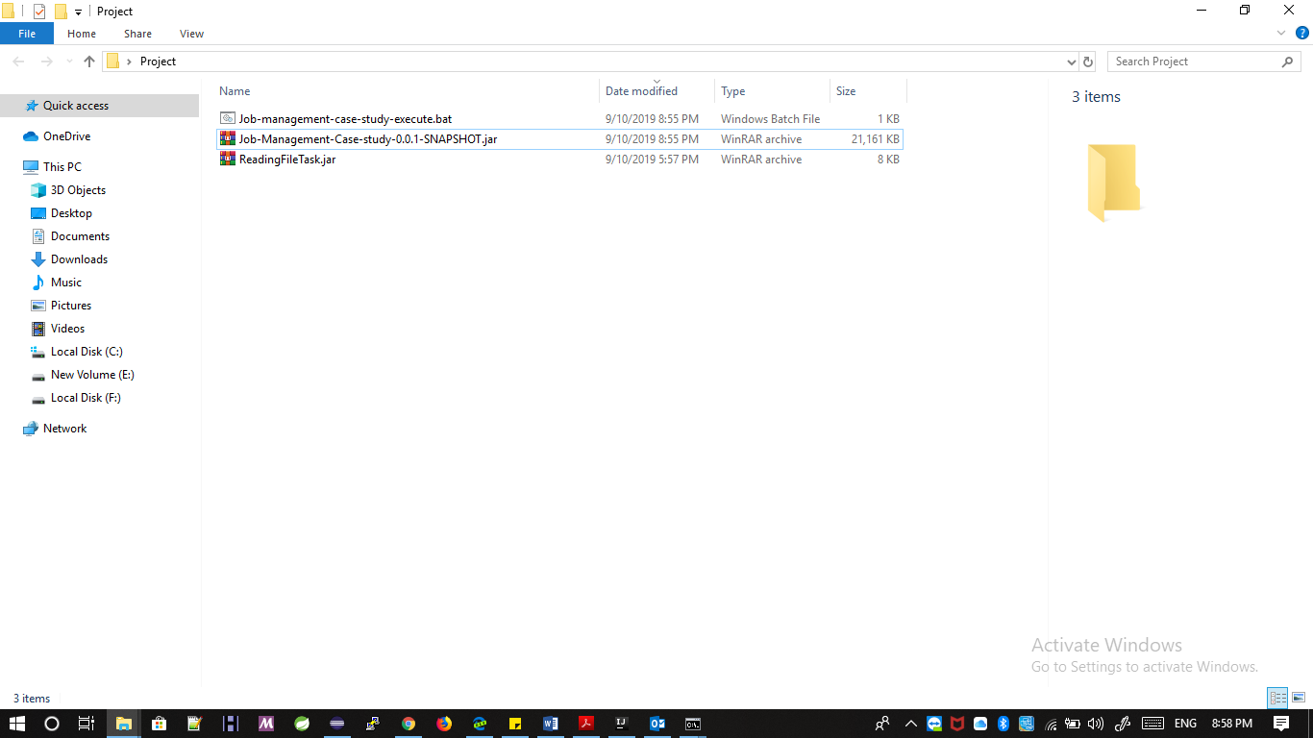

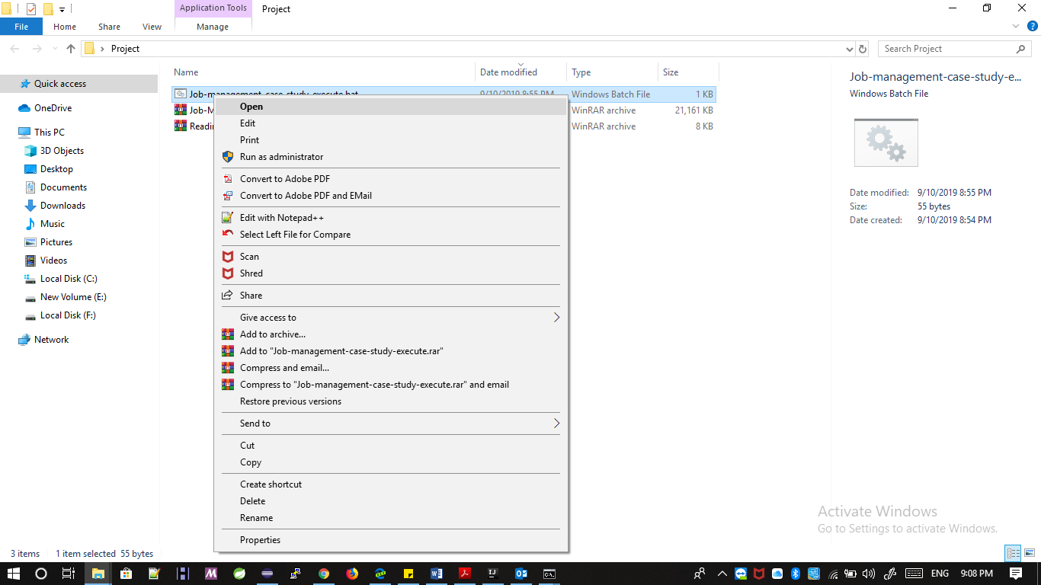

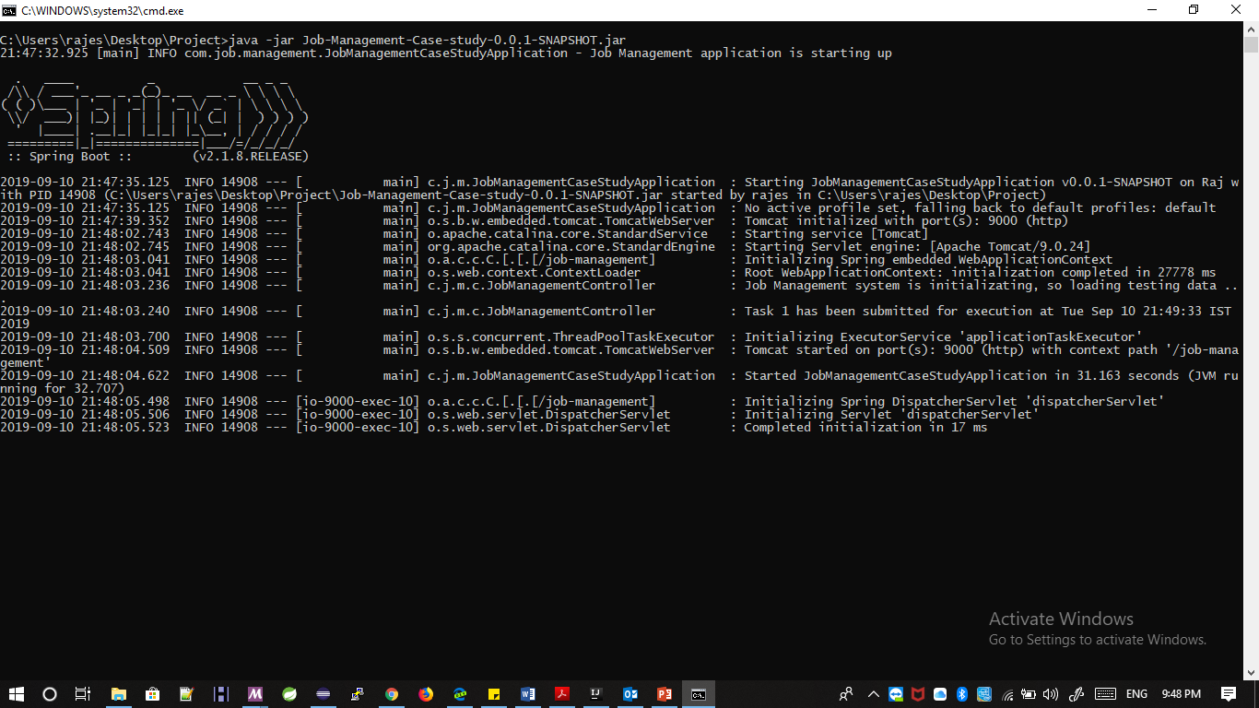

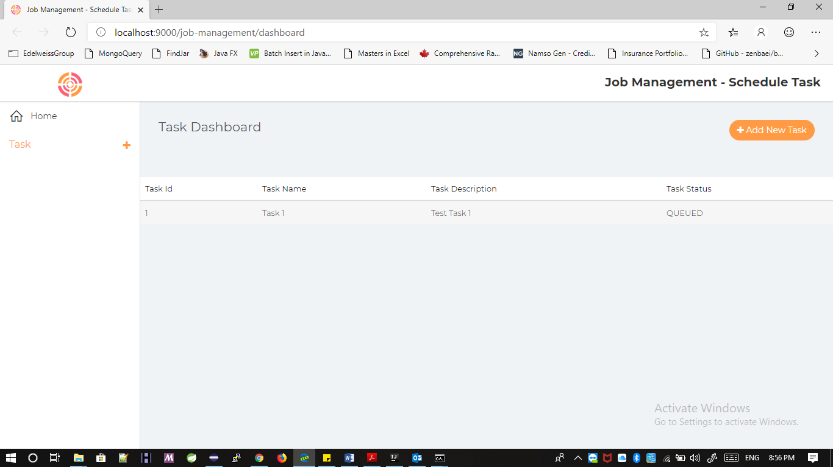

**Here you can add Task Manually by Clicking “*Add New Task*” button**

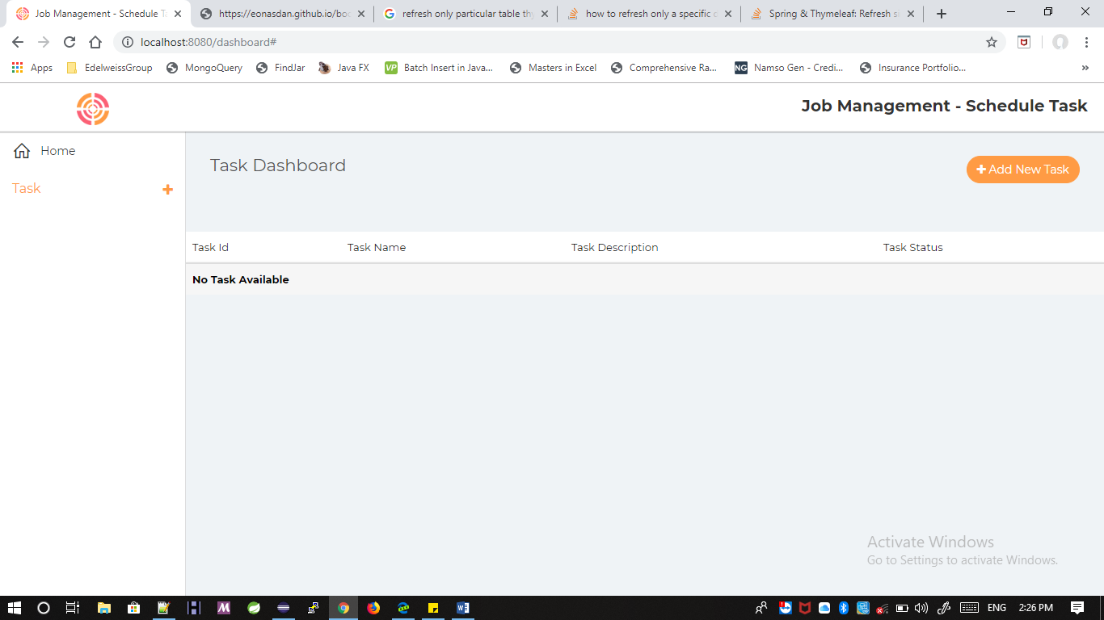

**Now fill the create Task form with following details(*This form should be filled within 20 sec otherwise page will be refreshed*) :**

* 1. Task Name
  2. Hour (*between 00-23, -1 indicates start executing immediately*)
  3. Minutes (*between 00-59, -1 indicates start executing immediately*)
  4. Priority (*HIGH,MEDUIM,LOW*) This features is not applicable
  5. Task Type (*Java, Python etc*) Currently applicable for Java only
  6. Choose Executable Batch file (***ReadingFileTask.jar*** *available in project folder which you have extracted now)*
  7. Task Description

**Note: This form has some basic validation**

1. Task name must contain 3 character
2. Hours text field should contains value from (-1 to 23 only)
3. Minutes text field should contains value from (-1 to 59 only)
4. Task type should be only Java
5. Task Description must contain 5 character

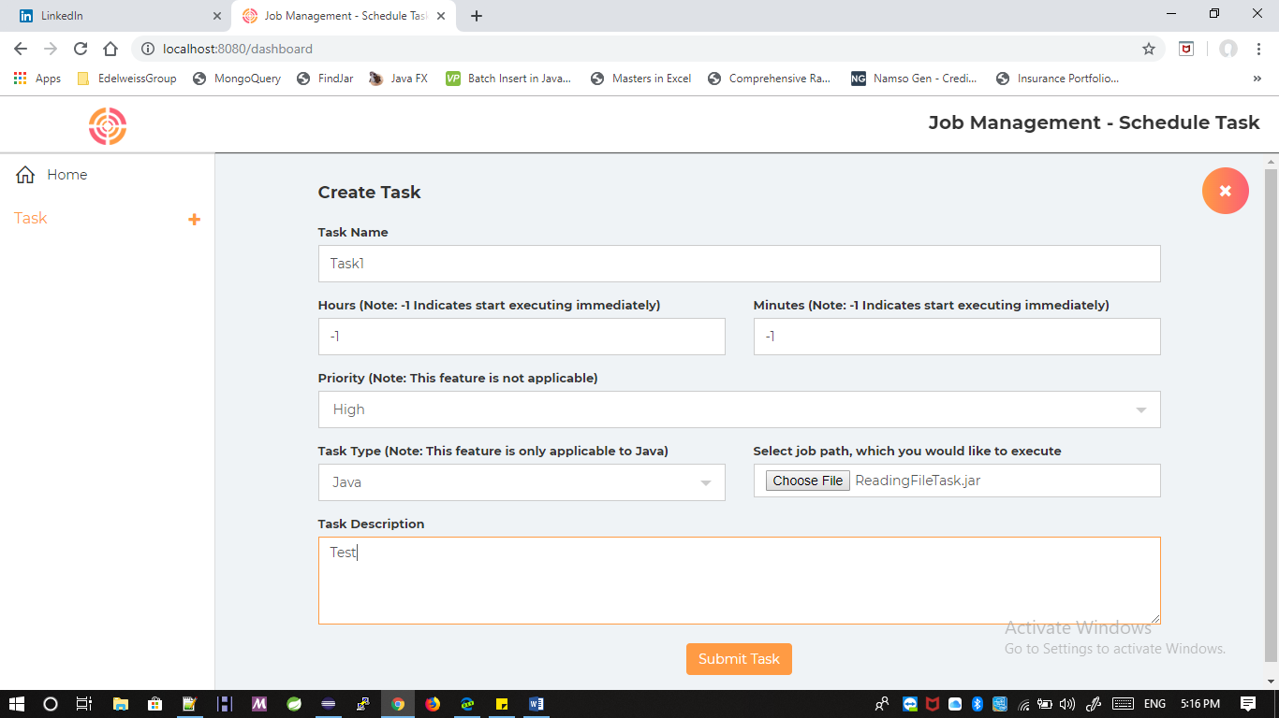

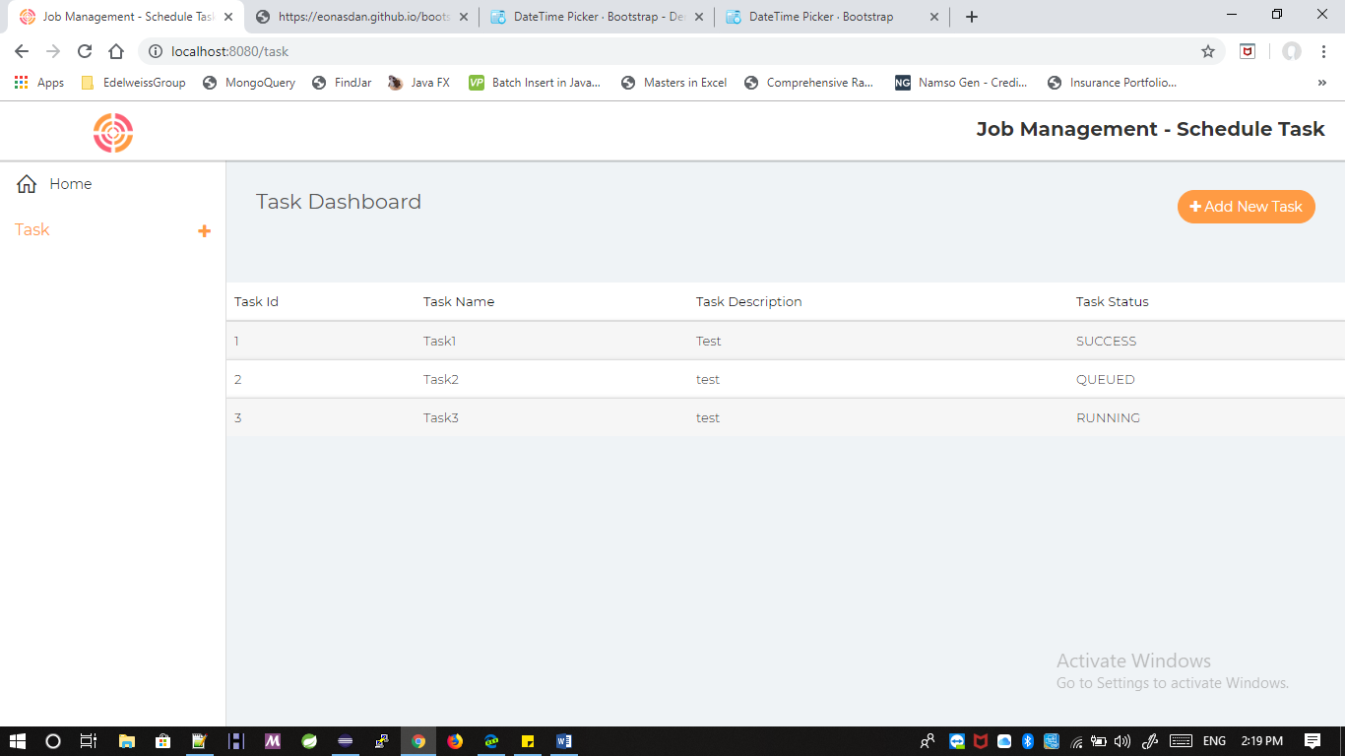

**How to stop this process:**

1. Open command promot which you have open just and process cntr+c (In windows)